APT Education Limited | Name:
Y7 1st Term Assessment Mock 1 (2019-2020) | Date:

Section A. Multiple Choice
1.
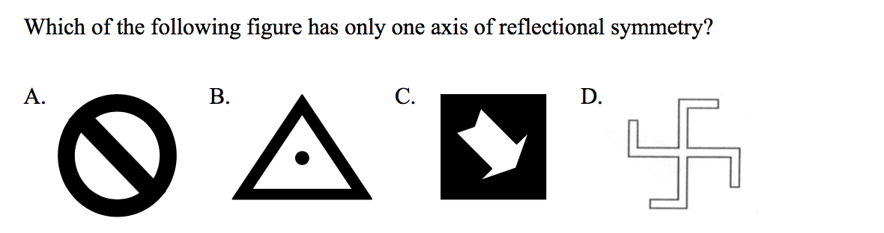
2.
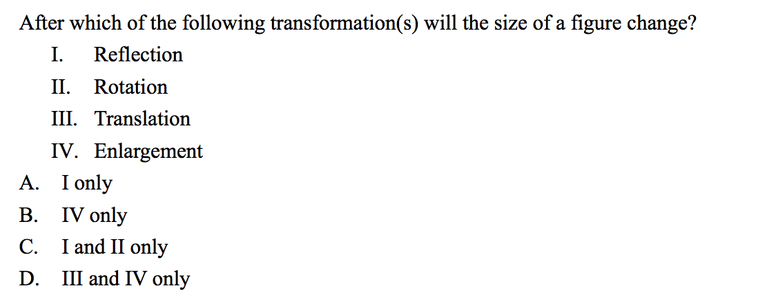
3.
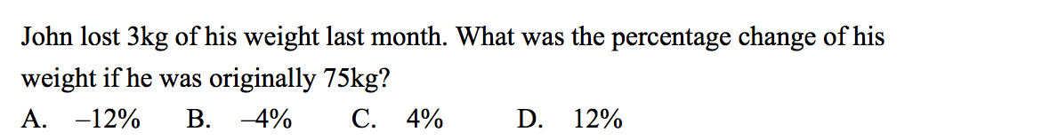
4.
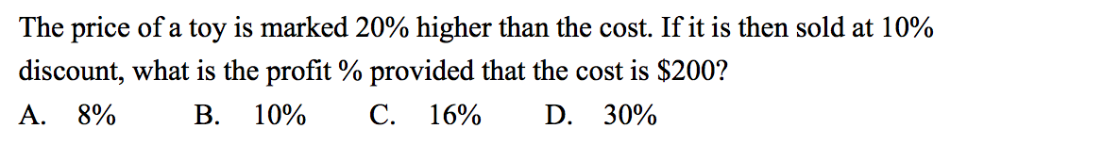
5.
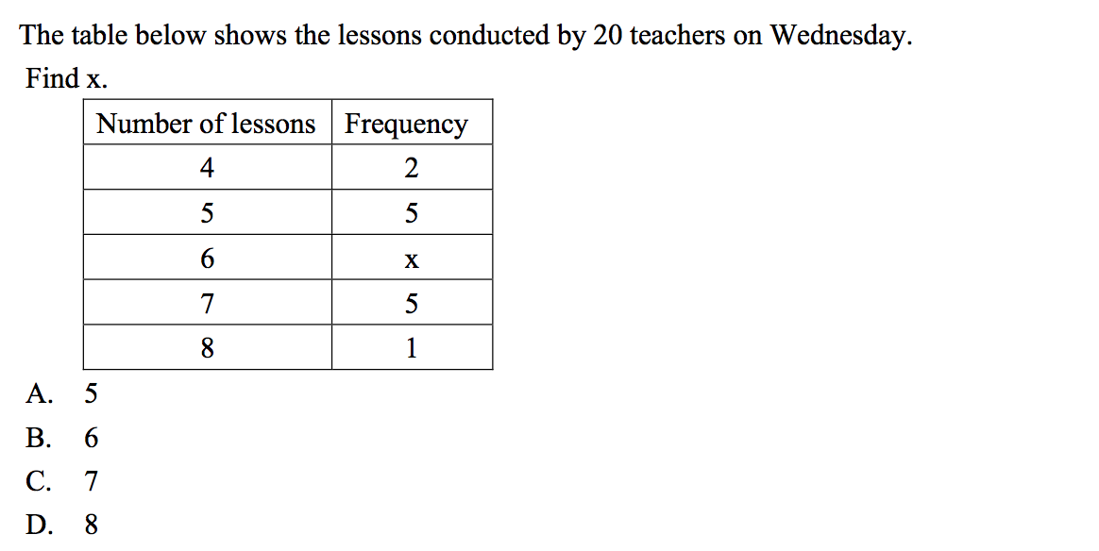
6.
7.
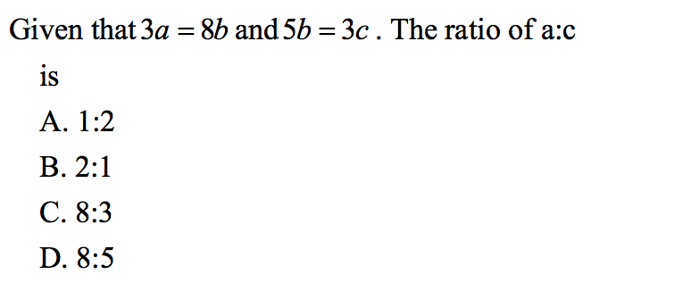

8.
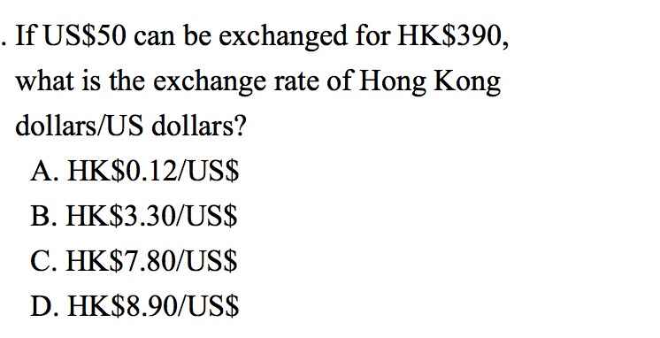
9.
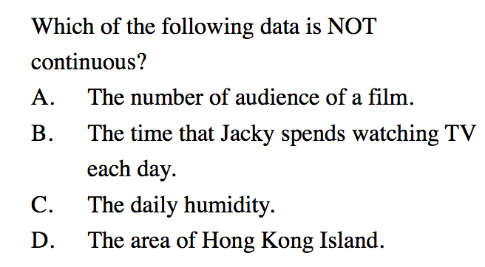

10. Refer to the following information and answer questions 16-17.
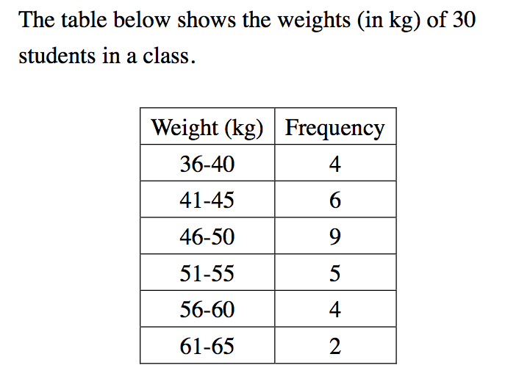
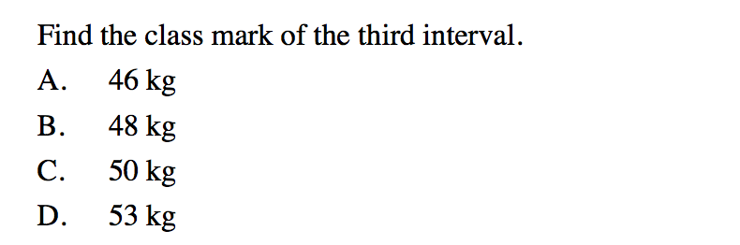
11.
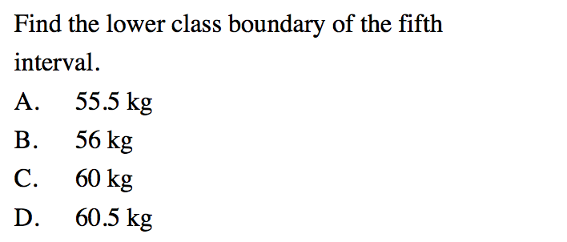

12. Refer to the following information and answer questions 18-19
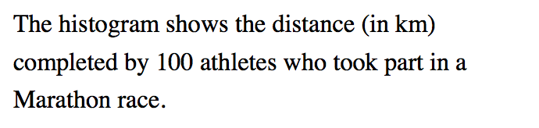
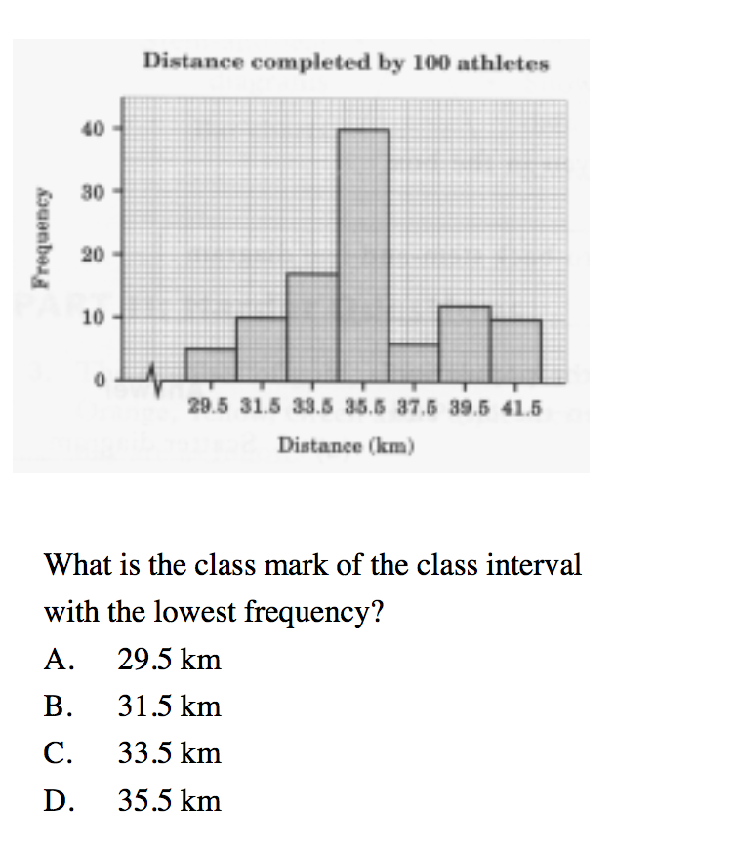

13.
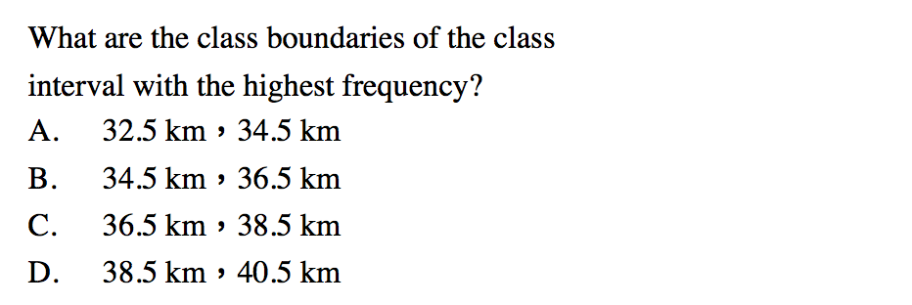
14. Refer to the following information and answer questions 20-21
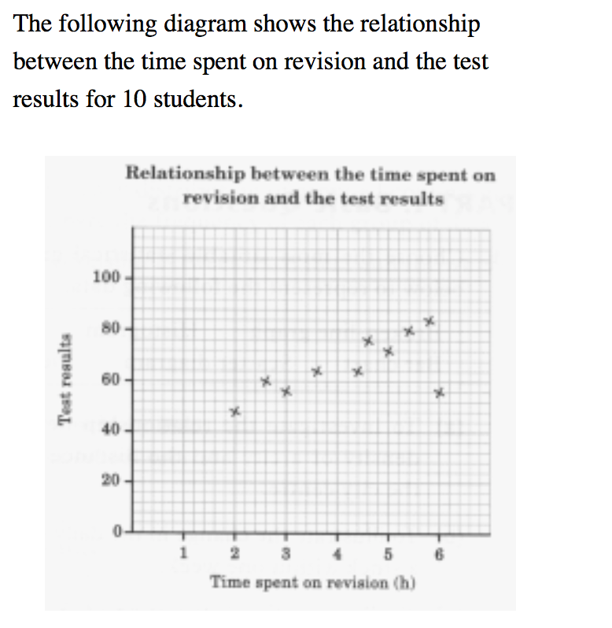
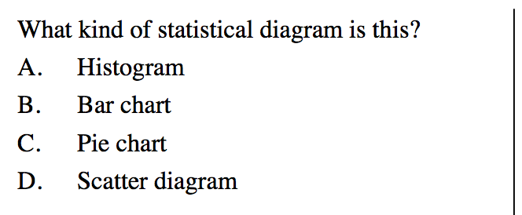

15.
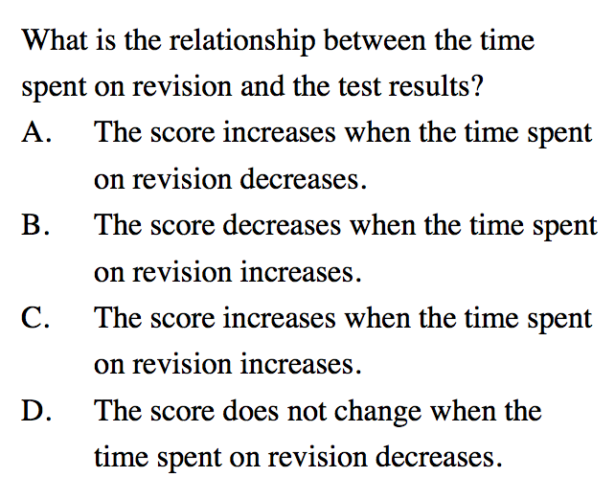
Section B Short Questions
1.
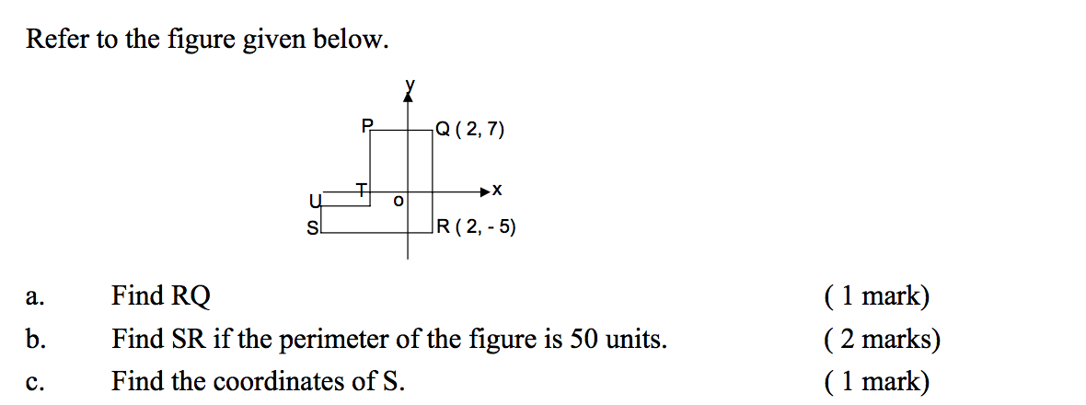

2.
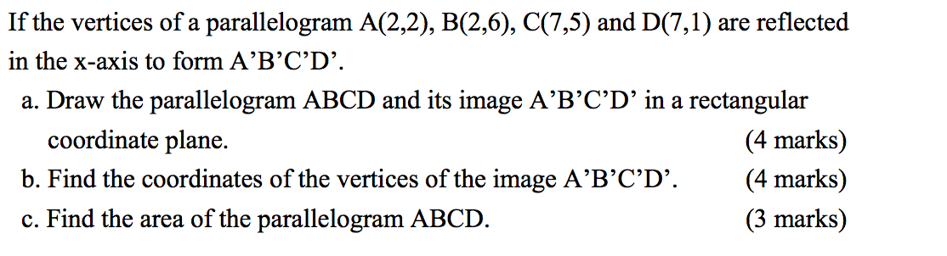
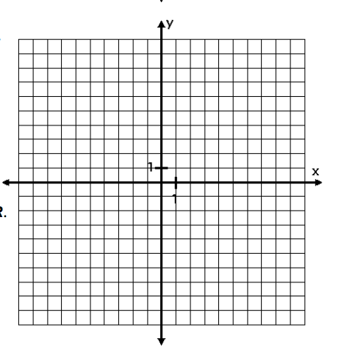

3.
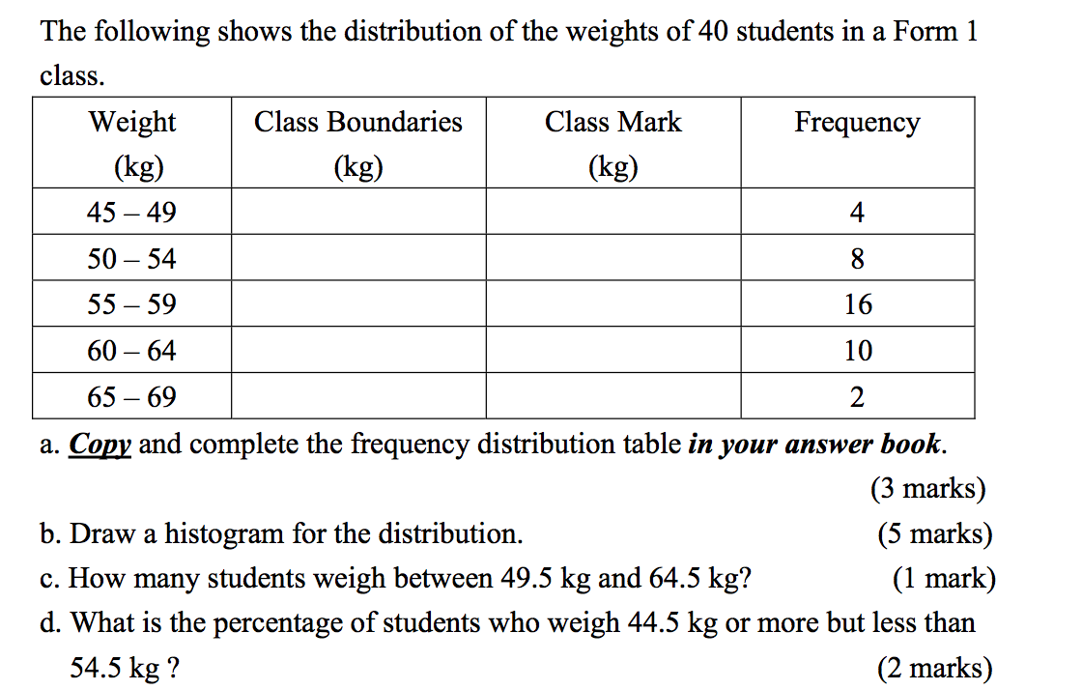
a.
Class Boundaries | Class Mark

b.
C.

d.

4.

5.
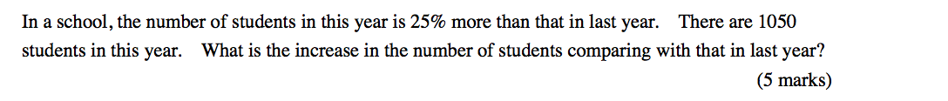

6.
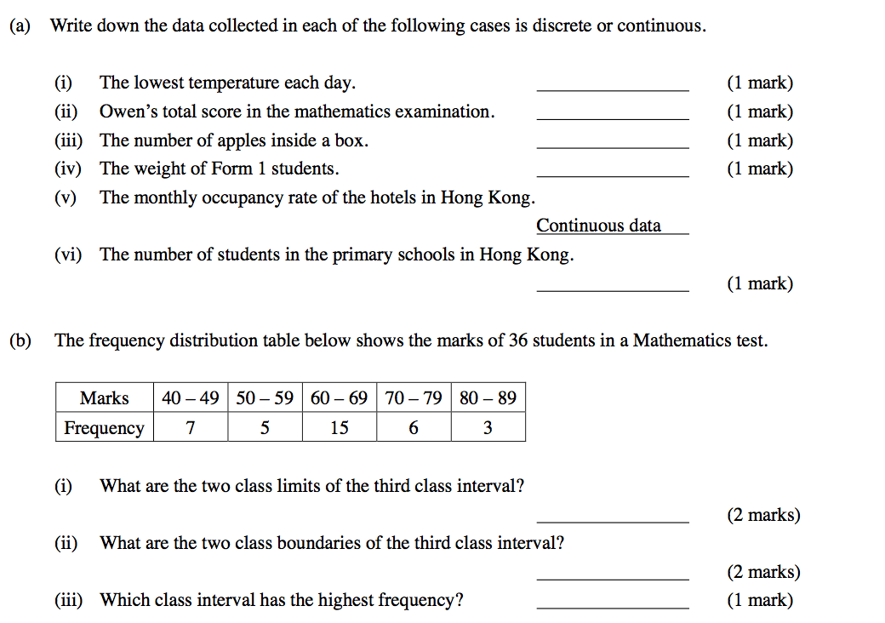
7.
X, Y and Z depart from place A at the same time and travel to place B.
If the times taken by them are in the ratio 12 : 10 : 15,
(a) who arrives at place B first? Why?
(b) what is the ratio of their speeds?

8.
The heights of Kenneth, Alex and Ivan are in the ratio 4 : 3 : 5. If Kenneth is taller than Alex by
35 cm, find the heights of Alex and Ivan.

9.
The selling price of an electrical appliance is $1 416 if it is sold at a profit rate of p%. The selling price is $984 if it is sold at a loss rate of p%.

(a) Find the value of p.

(b) Find the cost of the appliance.

(c) The marked price of the appliance is set with a 25% profit on its cost. If a minimum profit rate of 6.25% is wanted, find the maximum discount rate in selling the appliance.

10.
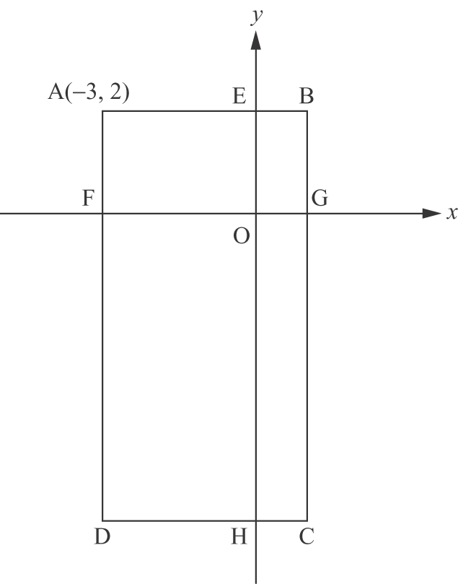
The above figure shows a rectangle ABCD. The coordinates of vertex A are (−3, 2). AB and DC intersect the y-axis at points E and H respectively. AD and BC intersect the x-axis at points F and G respectively, with AB // FG. It is given that the area of rectangle FGCD is 3 times the area of rectangle ABGF, and the area of rectangle ADHE is 3 times the area of rectangle EHCB.
(a) Find the coordinates of B, C and D.
(b) (i) Find the perimeter of rectangle ABCD
(ii) Find the area of rectangle ABCD.

11.
Suppose the cost of painting a wall is in proportion to the area of the wall. Given the cost of painting a 28 m (length) by 2.5 m (height) wall is $5 000. There is another wall of which the length is 50% longer and the height is 10% shorter than the wall mentioned above.
(a) Find the ratio of the area of the new wall to that of the given one.
(b) Find the cost of painting the new wall.

12.
1 | (a) In the figures above,  (i) which one(s) possess(es) only reflectional symmetry but do/does not possess rotational symmetry?  (ii) which one(s) possess(es) only rotational symmetry but do/does not possess reflectional symmetry?  (iii) which one(s) possess(es) both reflectional and rotational symmetries?  (iv) which one(s) do/does not possess reflectional symmetry nor rotational symmetry?  (b) In each of the above figures that possesses reflectional symmetry, draw all the axis/axes of symmetry using dotted line(s).  (c) Find the order of rotational symmetry for each of the above figures that possesses rotational symmetry.

13.
A cup is sold at $68 with a loss rate of 20%. A plate is sold at $45 with a profit rate of 25%. What is the profit rate or loss rate of selling a cup and a plate altogether? (Give the answer correct to 2 decimal places.)

14.
The labour fee and cost of material are 60% and 40% the total cost of producing a furniture respectively. The furniture produced is sold at a profit rate of 35%. If the labour cost increases by 20%, the material cost decreases by 10% and the selling price of the furniture increases by 15%, find the new profit rate.

